**PROJECT REPORT TEMPLATE**

**1. INTRODUCTION**

**1.1 Overview:**

A subscriber to a channel on the video-sharing YouTube is a user who has chosen to receive the channel's content by clicking on that channel's "Subscribe" button, and each user's subscription feed consists of videos published by channels to which the user is subscribed. The ability to subscribe to users was introduced in October 2005. YouTube began publishing a list of its most- subscribed channels in April 2006. An early archive of the list dates to May 2006.

The following table lists the 50 most-subscribed YouTube channels, as well as the primary language and content category of each channel. The channels are ordered by number of subscribers; those whose displayed subscriber counts are identical are listed so that the channel whose current growth rate indicates that its displayed subscriber count will exceed that of the other channel is listed first. Automatically generated channels that lack their own videos (such as Music and News) and channels that have been made effectively obsolete as a result of the transferal of their content (such as Justin Bieber VEVO and Taylor Swift VEVO) are excluded. As of February 2023, 21 of the 50 channels listed primarily produce content in English while 16 primarily produce content in Hindi.

All 50 of the channels have surpassed 40 million subscribers, 39 of them have surpassed 50 million subscribers, 23 of them have surpassed 60 million subscribers, 16 of them have surpassed 70 million subscribers, 12 of them have surpassed 80 million subscribers, 10 of them have surpassed 90 million and 7 of them have surpassed 100 million subscribers. Only 1 channel (T-Series) has surpassed 200 million subscribers.

**1.2 Purpose:**

Millions of videos are uploaded each day, creators face tough competition in audience attention. Standing out and new visitors can discover will be challenging. Advertisements aren't the only way YouTubers can make money and earn extra income. A YouTuber's salary comes from various other sources.

This is possible when we share the videos on social Media platforms, forums and online communities.

**2. PROBLEM DEFINITION & DESIGN THINKING**

**2.1 Empathy Map:**

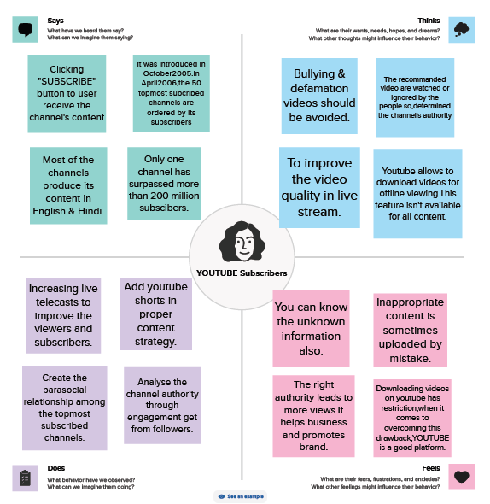

**2.2 Ideation & Brainstorming Map:**

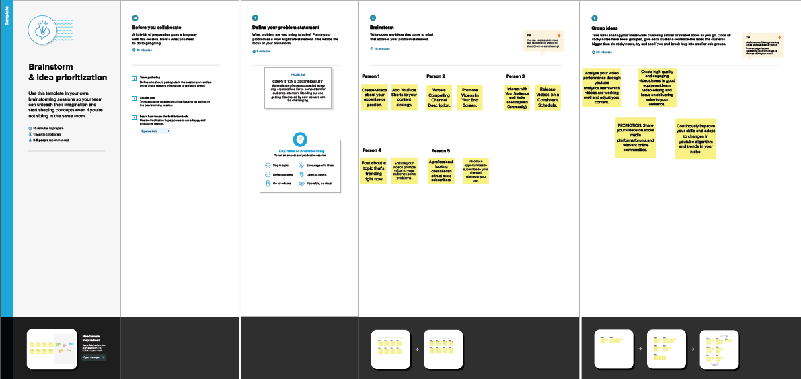

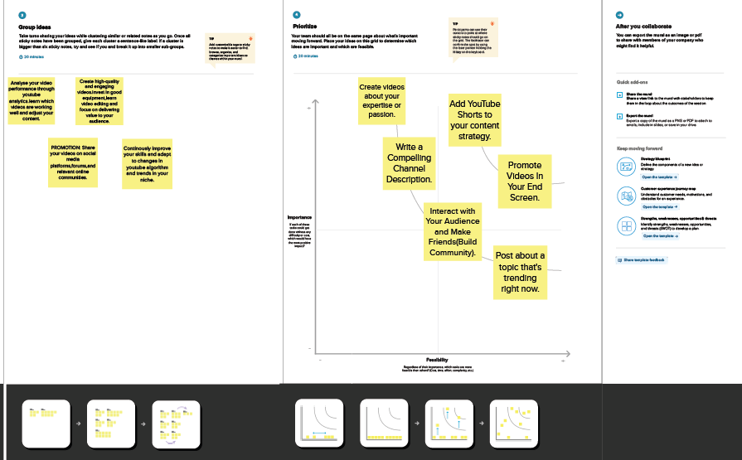

**3. RESULT**

**DASHBOARD:**

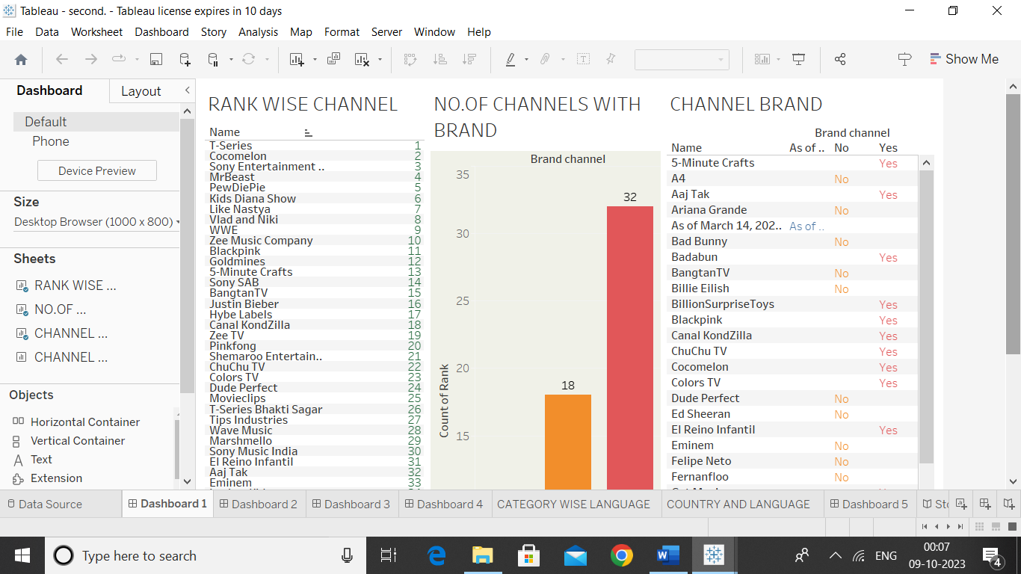

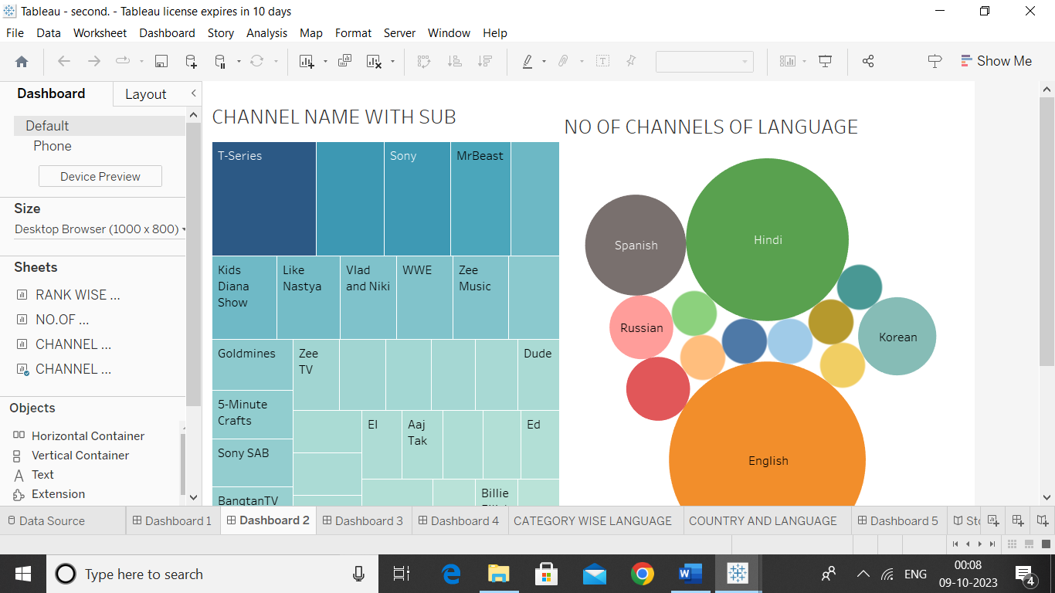

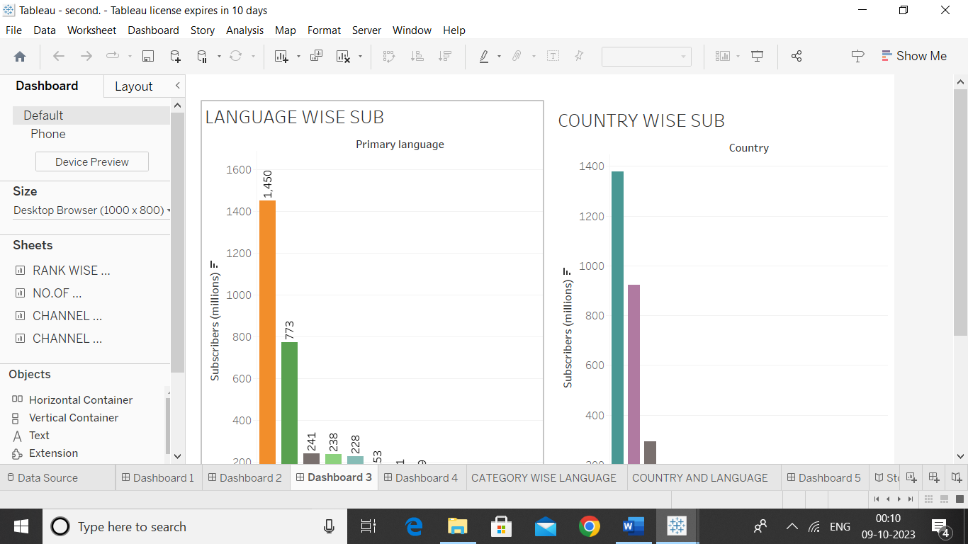

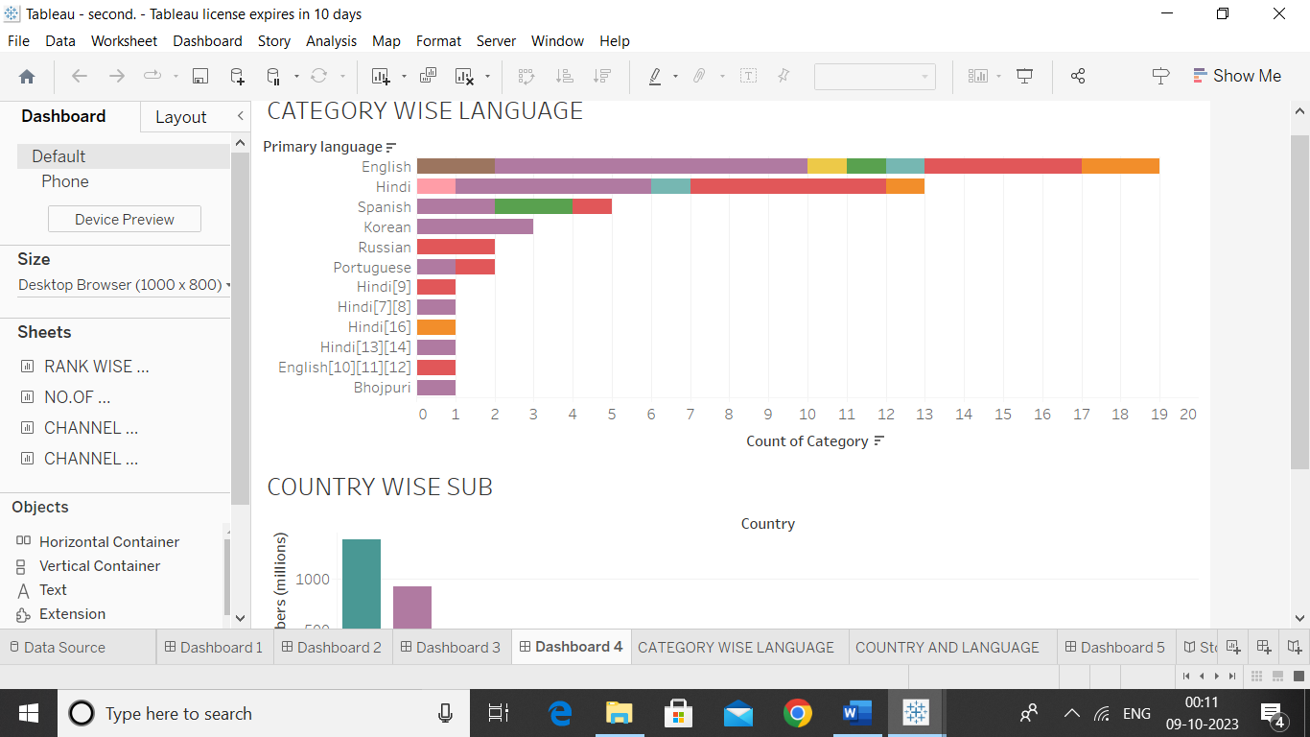

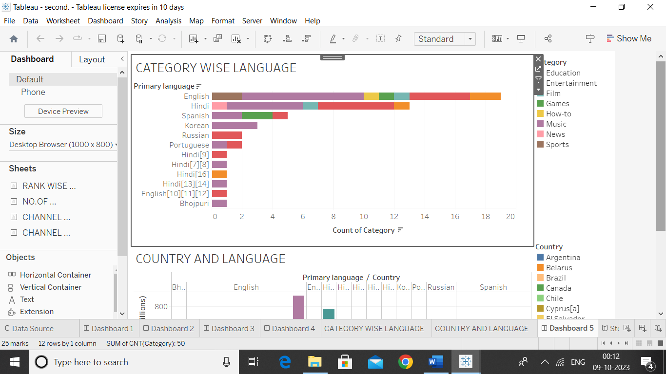

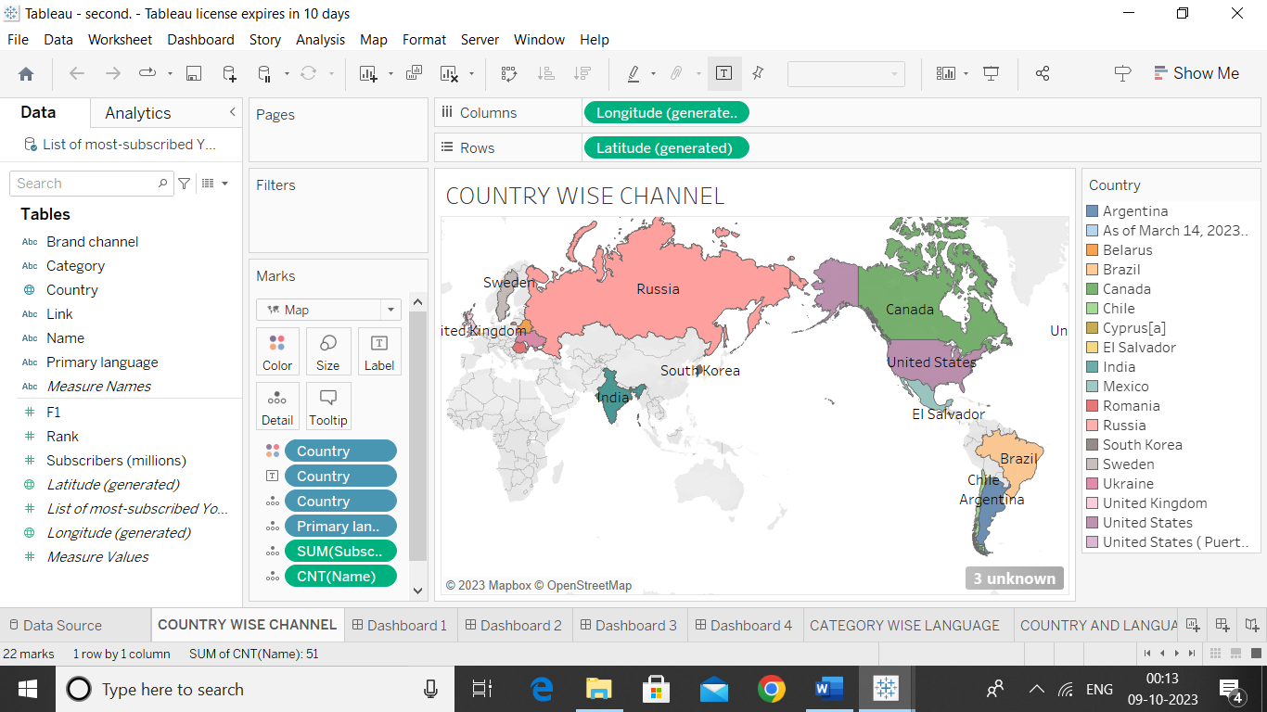

**STORY:**

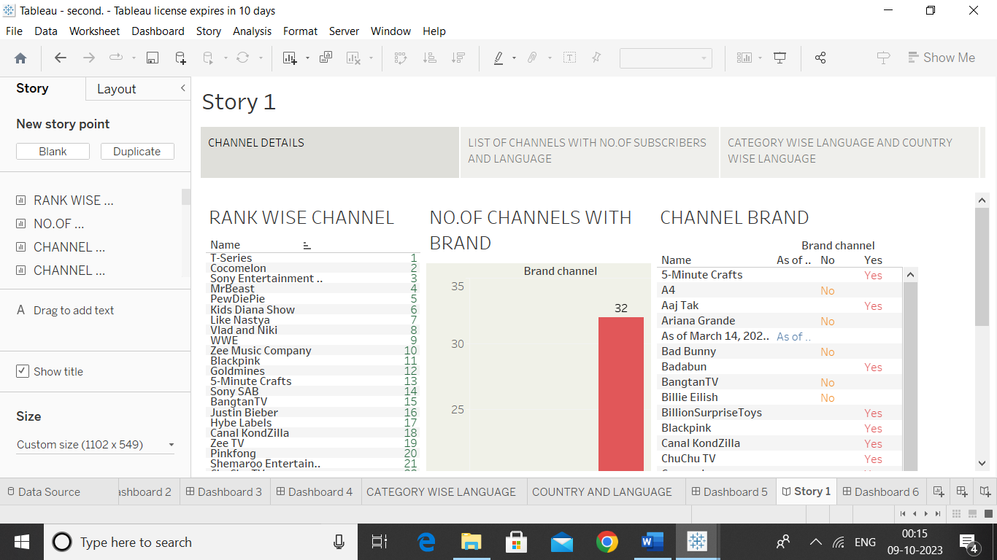

**4. ADVANTAGES AND DISADVANTAGES**

**ADVANTAGES :**

1. YouTube is the 2nd largest search engine and the 3rd most visited website worldwide, behind only Google and Facebook respectively.

2. 100 hours of video are uploaded every 60 seconds to YouTube.

3. According to Nielsen, YouTube reaches more US adults aged 18-34 than any cable networ**k.**

**DISADVANTAGES :**

1. Ads- a drawback of YouTube for the audience. when watching the YouTube videos, which include a lot of commercials. It is possible to skip your mainstream.

2. Many users misuse the platform to spread hate and chaos via content, causing tension between users. This is even when Google requests that users be respectful in their comments.

**5. APPLICATIONS**

1.Exposure to a Worldwide Audience. While other platforms may have certain parameters for their audiences, YouTube is extremely varied with users from all different ages, backgrounds, education levels, etc.

2.Gain Qualified Traffic. YouTube is perfect for gaining traffic that is qualified. When people are searching for direct phrases.

3.YouTube ads are managed and run through Google AdWords and AdSense.

**6. CONCLUSION**

YouTube has an important part in education, because it allows students to learn more about a particular topic or subject just by watching a short video. YouTube is full of different types of videos that can easily be incorporated and used in classrooms that will give students a better insight on a particular subject. There are many positive aspects to keep in mind about YouTube in comparison to the negatives.

**7. FUTURE SCOPE:**

1. The YouTube community is one of the most supportive communities in the world. It does this by rewarding creators for their hard work and dedication through upvotes, comments, and subscriptions. The YouTube platform has changed over time to make it easier for content creators.

2. YouTube will continue to be where people go for informative and educational videos. As more innovative technology comes out, YouTube will evolve with it.

3. YouTube users will be able to play and directly interact with Google’s technology. A current trend has people watching a video but then leaving the site and looking for more information about the content on Google.

4. According to the study, YouTube will merge with ISPs, cable, and wireless television to give viewers an all-in-one entertainment network.